**Mini Project Report on**



**Web Development using advanced tool.**



**Submitted in partial fulfillment of the requirement for the award of the degree of**

**BACHELOR OF TECHNOLOGY**

**IN**

**COMPUTER SCIENCE & ENGINEERING**

**Submitted by:**

**Student Name: Tushar Kukreti University Roll N: 2019190**

***Under the Mentorship of***

**Mr.Ramesh Singh Rawat**

**Assistant Professor**



**Department of Computer Science and Engineering**

**Graphic Era (Deemed to be University)**

**Dehradun, Uttarakhand**

**January 2023**



**CANDIDATE’S DECLARATION**

I hereby certify that the work which is being presented in the project report entitled **“Title of the project”** in partial fulfillment of the requirements for the award of the Degree of Bachelor of Technology in Computer Science and Engineeringof the Graphic Era (Deemed to be University), Dehradun shall be carried out by the under the mentorship of **Mentor Name, Designation**, Department of Computer Science and Engineering, Graphic Era (Deemed to be University), Dehradun.

Name :Tushar Kukreti   University Roll no : 2019190 **signature**

**Table of Contents**

|  |  |  |
| --- | --- | --- |
| **Chapter No.** | **Description** | **Page No.** |
| Chapter 1 | Introduction |  |
| Chapter 2 | Literature Survey |  |
| Chapter 3 | Methodology |  |
| Chapter 4 | Result and Discussion |  |
| Chapter 5 | Conclusion and Future Work |  |
|  | References |  |

**Chapter 1**

**Introduction**

**(2 to 3 pages)**

1. **Introduction:**

**1.1 History:**

Admission management is a crucial process for educational institutions .Traditional college admission is a hectic process, which involves students visiting off-site campus, taking application, filling it, and then the submission is another hectic story, and then it involves the collection, review, and acceptance of student applications by college’s department. The process is time-consuming and requires a significant amount of coordination and communication between different departments. On the day of admission, the flow of candidates is very high and it requires both manual processing and record-keeping at the same time that makes the process lengthy and difficult to keep track of the admission status of a candidate in multiple departments.

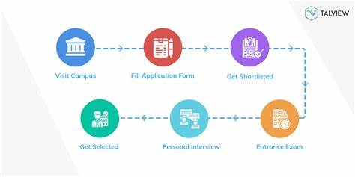

Fig 1.1. Stages of old admission management.

1.2 Introduction to Web development :

This college admission management system helps to make the admission process much easier and helps in maintaining a database in an efficient way. As of now, College Admission Management System is considered an institution of its own, not a general admission management system.

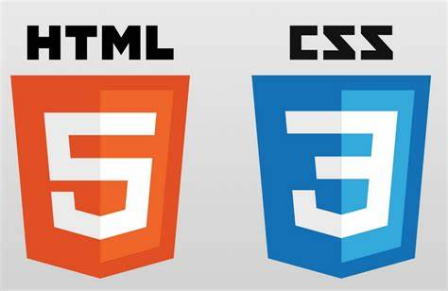

Fig. 1.2. Html and CSS

With the increasing trend of digitalization, the use of web development technologies has become increasingly popular as a way to streamline and automate the admission process. This project aims to develop a web-based admission management system using HTML, CSS, Flask, and SQLite3.



Fig. 1.3. Flask

With the increasing trend of digitalization, the use of web development technologies has become increasingly popular as a way to streamline and automate the admission process. This project aims to develop a web-based admission management system using HTML, CSS, Flask, and SQLite3.



Fig. 1.4. SQLite

The main objective of this project is to create a web-based admission management system that can be used to automate the process of collecting, reviewing, and accepting student applications. The system will be designed to be user-friendly and easy to navigate, and it will be built using a combination of web development technologies such as HTML, CSS, Flask, and SQLite3. The system will be able to handle the entire admission process, from application submission to decision notification and enrollment management.

The system will allow students to apply for admission by submitting their personal information and academic records online. The system will also provide a platform for staff members to log in and access the applicant's information, review the applications, and make decisions on the acceptance of the applicants. The system will be able to generate reports and analytics to track the performance of the admission process.

The use of Flask, a lightweight and flexible web framework for Python, and SQLite3, a self-contained, serverless, zero-configuration, transactional SQL database engine, will provide a robust and efficient solution for admission management. It will be easy to deploy and maintain, making it suitable for small and medium educational institutions. The system will also be designed to be secure and compliant with regulations related to student data privacy. This will be achieved through the implementation of proper authentication and authorization mechanisms, as well as encryption of sensitive data.

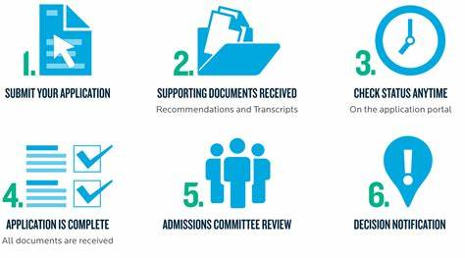  
 fig. 1.5. Steps for online college admission.

The purpose of this project is to develop an Admission Management System (AMS) using web development advanced tools. The system will allow educational institutions to manage the process of admitting students, including applications, evaluations, and decisions. The AMS will be accessible to both administrators and applicants through a web interface. The AMS will provide a user-friendly interface for applicants and administrators, streamline the process of admitting students, and reduce the likelihood of errors.

**Chapter 2**

**Literature Survey**

* First ,create a folder (for eg. Flask project) and create a folder in it named it (for eg. env) and another one named it Templates .

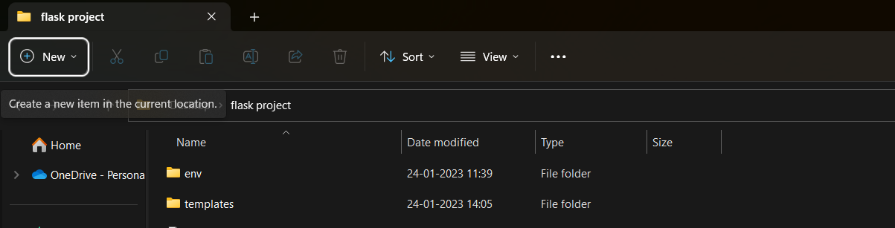

* Download latest version of python from www.python.com

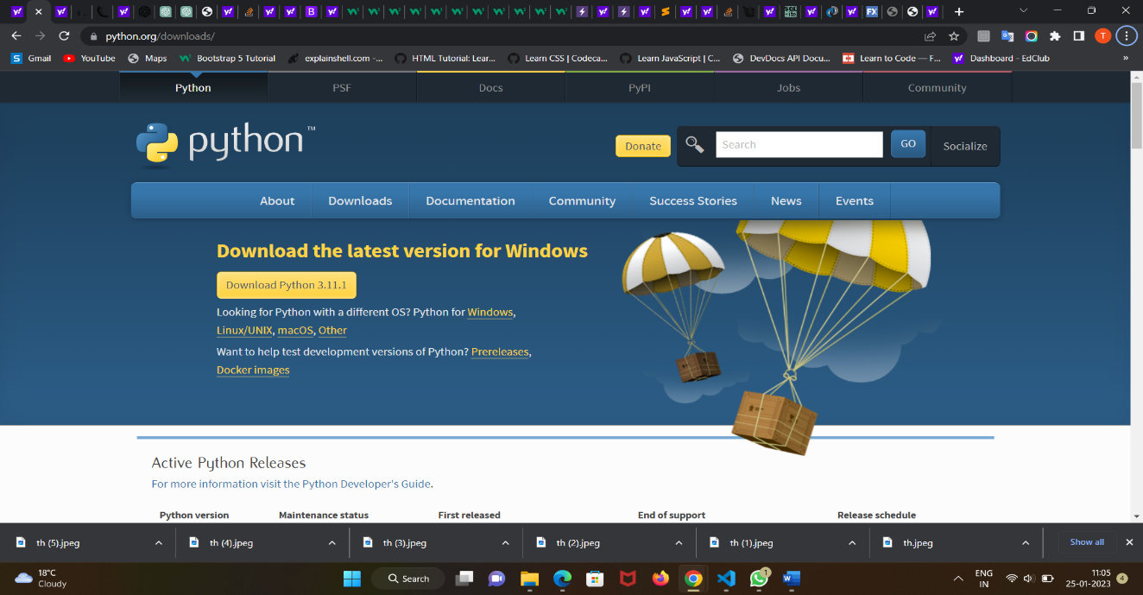

* Open current folder i.e flask project folder in Visual Studio Code. And run command pip install virtualenv

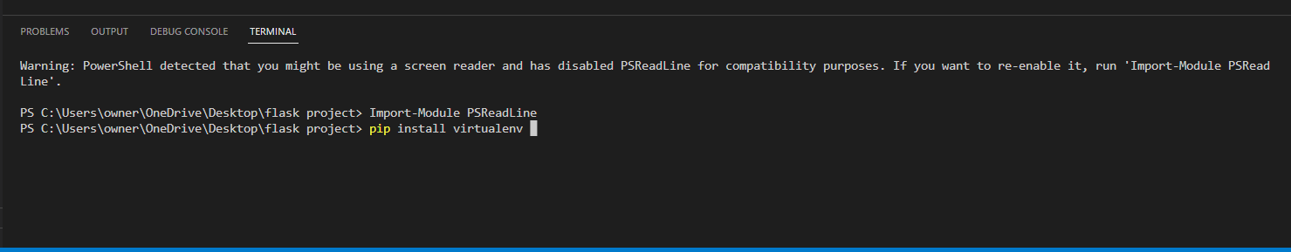

* Type command virtualenv env to create a virtual environment for our programming.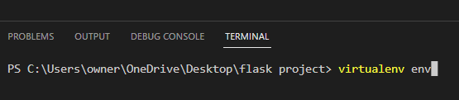
* Type command .\env\Scripts\Activate.ps1 to activate virtual environment .

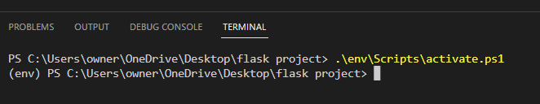

* Now install flask in virtual environment env by typing command . pip install flask

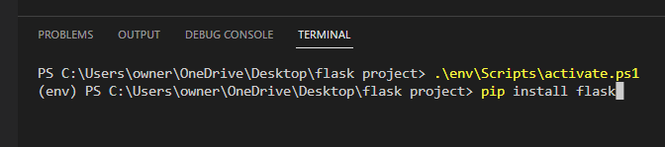

* Now you can use flask for web development but always remember minimal flask application syntax

.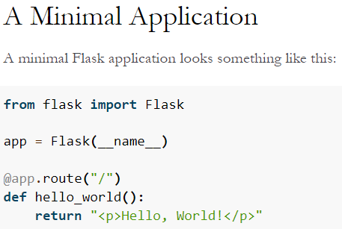

* Create a new python file in this folder and named it “app.py”.This will be main application of your website.
* Add as many route as required in the project .
* In template folder , add html file containing html,css and bootstrap structure. Use different html file for different route ,if they donot have comman function.
* Finally ,test your website by typing command env .\app.py

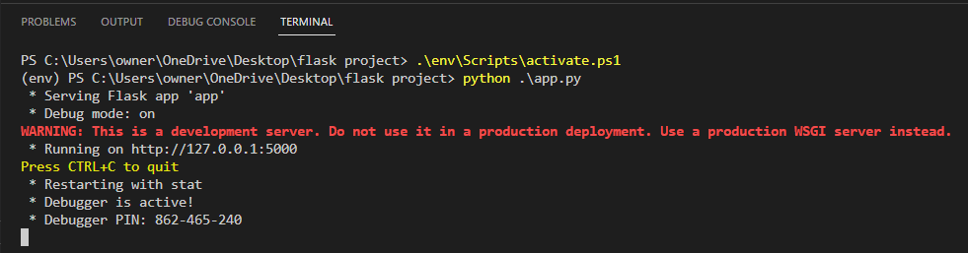

**Chapter 3**

**Methodology**

Explain your methodology using phrases, flowcharts, detailed diagrams, etc.

**(2 to 3 pages)**

**Chapter 4**

**Result and Discussion**

This section will contain all your results from the above methodology used.

The result could be graphs, diagrams, tables, matrices, etc.

**Chapter 5**

**Conclusion and Future Work**

This section will contain the conclusion of your work. Further contains vision and ideas about future methods or new solutions to your current problem statement.

**References**

 [1] N. K. Kanhere and S. T. Birchfied, “Real-time incremental segmentation and tracking of vehicles at low camera angles using stable features,” *IEEE Trans. Intell. Transp. Syst*., vol. 9, no. 1, pp.148-160, March 2008 **(Example : Journal papers)**

 [2] K. Onoguchi, “Moving object detection using a cross correlation between a short accumulated histogram and a long accumulated histogram”, Proc.   18th Int. Conf. on Pattern Recognition, Hong Kong, August 20 - 24, 2006, vol. 4, pp. 896 – 899 **(Example : Conference papers)**

[3] T. H. Cormen, C. E. Leiserson, R. L. Rivest and C. Stein, “Introduction to Algorithms”, 2nd ed., The MIT Press, McGraw-Hill Book Company, 2001 **(Example : Text Book/ Magazine)**

[4]Open Source Computer Vision (OpanCV) [Online]. Accessed on 21st April 2022: <http://opencv.willowgarage.com/wiki/> **(Example : Website)**